# CHAPTER 1

## INTRODUCTION

Agriculture is an important part of the Indian economy, producing a broad variety of fruits, vegetables, and grains for both internal and export consumption. In terms of fruit output, India is ranked second in the world. When choosing a fruit to buy, smell, shape, and colour are all significant elements to consider. For image classification, we take into account shape and colour in this application. It’s critical to spot any bacterial or fungal development on fruits since they can cause havoc should they become mixed in with the good ones, resulting in a loss of yield.

Transfer Learning, on the contrary, is a machine learning approach that utilizes a previously trained machine learning model to produce a new model that is used to tackle a distinct but interrelated problem. When a smaller data set is available and computational capacity is limited, using a pre-trained machine learning model to generate a new model is more efficient way to approach the problem.

In our implementation we will be employing a machine learning model MobileNetV1 that is pre-trained with Image- Net database .In addition to this will also be Fine-Tuning our model, where we will be freezing the initial layers of the model except the last 5 layers and re-training the model to classify the images based on the new data with a very low learning rate to detect the quality of fruits and vegetables.

## Overview:

Image classification plays a vital part in the detection and segregation of fruits for their quality by considering parameters such as color, shape, deformation and scabs We compare two techniques, CNN and Transfer Learning, to develop a model that can do these tasks quickly and efficiently. With an accuracy of 92.66, the CNN technique requires a large data set, as well as a lot of computing power, GPU, and time. When given a small data set, low computing resources, and a GPU, transfer learning performs better, with an accuracy of 95.42 in substantially less time. By evaluating the model, we can affirm that a combination of Transfer Learning with fine tuning enhances the performance of the classification model.

## Problem Statement:

To detect the quality of the fruits and vegetables using image classification and object detection. Defect or damage usually occurs in fruit and vegetables due to various factors such as rotting, bruising, scab, fungal growth, injury, disease etc. The image classification helps to identify the rotten/defected fruit and object detection helps in detecting it in real-time.

# CHAPTER 2

## LITERATURE SURVEY

Deep learning-based low-cost machine vision system for grading the fruits based on their outer appearance or freshness. Various state-of-the-art deep learning models and stacking ensemble deep learning methods were applied to two data sets of fruits.

A framework for learning and classifying bananas is developed first. It uses neural network technology to detect the fruit's ripening stage. Due to the complexity of the banana fruit's ripening stages, it is necessary to develop image processing tools that can identify the various fresh incoming bunches. The goal is to create an image processing system that can detect the different stages of the fruit's ripening process. This method would help determine the optimal eating quality and the price of bananas.

Computer vision is a widely used technique for processing images. In this paper, we study the various aspects of machine learning for the classification of fruits and vegetables. Through a variety of data sources, we found that SVM achieves better accuracy than other machine learning techniques. We perform the Recognition and classification of fruits and vegetables and detection of disease in fruits and vegetables among the horticulture products under the agriculture field using computer vision.

This paper proposed a classification model for maturity status classification of papaya fruits in two approaches, machine learning and transfer learning approach. Overall, the VGG19 is better as VGG19 is based on transfer learning, there is no requirement of feature extraction and feature selection process. Although the transfer learning approach needs complex architecture, high training time and large data sets it is one time only. However, the achieved accuracy in both machine learning and transfer learning is 100% and beat the previous method i.e., 94.7% of accuracy.

A deep learning-based framework for fruit classification was proposed in this work. The proposed paper tells us they have created a fuzzy model to check whether the fruit banana is ripe, unripe or overripe. For this they have used Regression Tree Algorithm and also the classification method. This process is evaluating the banana on different ripening stages on the MUSA database.

The proposed paper gives the information that Convolution Neural Network has feature extraction which can be used for object recognition, semantic segmentation and image super-resolution. For object recognition we can use CNN architecture such as AlexNet,VGG16 and VGG19.For hybrid classification we will be using the CNN architecture along with support vector machine classifier.VGG19 CNN Architecture is best comparing with the others.

Women Deep Learning is machine learning technique which depends on supervised, semi supervised and unsupervised learning. For image processing, computer vision and pattern recognition. In working part first it will be working on Deep Neural Network in Deep Learning area and then convolution neural network and the are LeNet, AlexNet, GoogleNet, VGG16, VGG19, Resnet50 etc.

In this paper, it has been discussed there may arise a human error while checking the quality of the fruit so using image acquisition and image classification for checking the fruit quality and three important factors used are image segmentation, image pre-processing, Classifier. In addition to this k-means clustering is used to achieve better improvement of accuracy and speed of the classifier.

In this proposed paper, it is discussed about apple defect detection where first the apple image is captured and then background are deleted and the algorithm used in this paper is e Fuzzy C-means Algorithm and the Nonlinear Programming Genetic Algorithm (FCM-NPGA) and for multivariate image analysis. Using this algorithm the image of apple that is apple is examined every angle so that the defect can be found easily.

# CHAPTER 3

## SYSTEM ANALYSIS

### MOBILENET V1:

MobileNets are small, low-latency, low-power models parameterized to meet the resource constraints of a variety of use cases. They can be built upon for classification, detection, embeddings and segmentation similar to how other popular large scale models, such as Inception, are used. MobileNets can be run efficiently on mobile devices with TensorFlow Lite. MobileNets are a family of mobile-first computer vision models for TensorFlow, designed to effectively maximize accuracy while being mindful of the restricted resources for an on-device or embedded application. MobileNets trade off between latency, size and accuracy while comparing favorably with popular models from the literature.

MobileNet is a type of convolutional neural network designed for mobile and embedded vision applications. They are based on a streamlined architecture that uses depth wise separable convolutions to build lightweight deep neural networks that can have low latency for mobile and embedded devices.

The MobileNet model is based on depth wise separable convolutions which is a form of factorized convolutions which factorize a standard convolution in to a depth wise convolution and a 1×1 convolution called a pointwise convolution. For MobileNets the depth wise convolution applies a single filter to each input channel. The pointwise convolution then applies a 1×1 convolution to combine the outputs the depth wise convolution. A standard convolution both filters and combines inputs into a new set of outputs in one step. The depth wise separable convolution splits this into two layers, a separate layer for filtering and a separate layer for combining. This factorization has the effect of drastically reducing computation and model size.

### CONFUSION MATRIX:

### In the field of machine learning and specifically the problem of statistical classification, a confusion matrix, also known as an error matrix, is a specific table layout that allows visualization of the performance of an algorithm, typically a supervised learning one (in unsupervised learning it is usually called a matching matrix). Each row of the matrix represents the instances in an actual class while each column represents the instances in a predicted class, or vice versa – both variants are found in the literature.The name stems from the fact that it makes it easy to see whether the system is confusing two classes (i.e. commonly mislabeling one as another).

### It is a special kind of contingency table, with two dimensions ("actual" and "predicted"), and identical sets of "classes" in both dimensions (each combination of dimension and class is a variable in the contingency table).

### REACT JS:

### React makes it painless to create interactive UIs. Design simple views for each state in your application, and React will efficiently update and render just the right components when your data changes.

### Declarative views make your code more predictable and easier to debug.

### 3.4 System Specification:

#### Software Specification

This application is been designed to run as a desktop application with part of the data saved on server for security purpose.

#### Server Machine:

* + - * Operating System: Windows Desktop OS
      * Framework: Jupyter
      * Front end : ReactJS

**CHAPTER 4**

## DESIGN AND IMPLEMENTATION

### System Flow:

* First, dataset is pre-processed by constructing an input pipeline, in this instance Keras ImageDataGenerator, and running the pre-processing function, which turns the data into a format that the mobilenet understands and normalises the RGB pixels to a range of -1 to 1.
* This pre-processed dataset is used to train mobilenet for transfer learning.
* Modification to the fully connected layer is performed and a dense layer to classify the 6 different classes of the dataset using the softmax activation function is added as we are performing multi- classification.
* The last 5 layers of the model is then fine-tuned and re-trained with a low learning rate on the dataset to assure better performance.
* Finally, model is trained for 50epochs and attain a training accuracy of 100% and a validation accuracy of 99.58%, with a training and validation loss of 0.35% and 1.8%, respectively.
* The training is then checked against the validation set for accuracy and loss, as well as to verify if the model is overfitting or underfit.
* Once the prediction model is complete, we pass our test set to the model, which then produces a classification of fruit quality.
* Once the model is ready, it is integrated with the frontend and made available to the user.

### FLOWCHART:

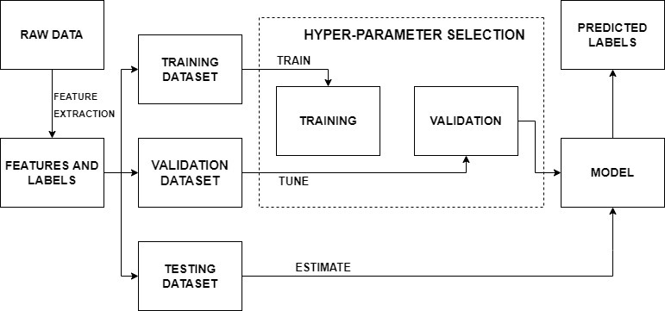

**FIG 4.1 FLOWCHART**

The Fig 4.1 shows the flowchart of working model. First, the raw data, which are the images of the fruits are collected and fed into the pre-trained model which is trained with more datasets to get greater accuracy. After feature extraction process the dataset is divided into training dataset, validation dataset and testing dataset. The training dataset is sent for training and the validation datasets are sent for fine tuning the model. Once this process is done the training results are tested are tested with the testing datasets. Hence at the final stage the model gives out the predictions.

**4.3** **BLOCK DIAGRAM:**

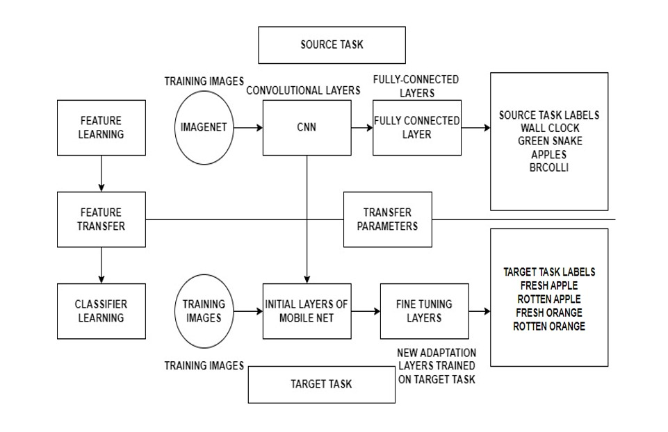

**Fig 4.2. Block Diagram of Deep learning**

The Figure 4.2 shows the block diagram of deep learning. The block diagrams explains the working of the model in detail, where the datasets are fed into the model and the feature extraction takes place and gives out training dataset, validation dataset and testing datasets. The training datasets are used to train the model and the validation datasets are used to fine tune the model during training. The model used here is mobilenet v1 which has several layers of neural network in it. The model is already pre-trained. This model is trained with huge amount of datasets to get the greater accuracy in prediction. The last few dese layers in the model is removed and trained with our datasets to get favorable accuracy of the model.

**4.4 CATEGORICAL CROSSENTROPY:**

Categorical crossentropy is a loss function that is used in multi-class classification tasks. These are tasks where an example can only belong to one out of many possible categories, and the model must decide which one.Formally, it is designed to quantify the difference between two probability distributions.

The categorical crossentropy is well suited to classification tasks, since one example can be considered to belong to a specific category with probability 1, and to other categories with probability 0.

The model uses the categorical crossentropy to learn to give a high probability to the correct digit and a low probability to the other digits.

Softmax is the only activation function recommended to use with the categorical crossentropy loss function. The softmax activation rescales the model output so that it has the right properties. Use a single Categorical feature as target.

This will automatically create a one-hot vector from all the categories identified in the dataset. Each one-hot vector can be thought of as a probability distribution, which is why by learning to predict it, the model will output a probability that an example belongs to any of the categories.

# CHAPTER 5

## TECHNOLOGY STACK

Our platform was designed and developed using various technology stack in order to provide good accuracy in detecting the quality and shelf life of the fruits and vegetables.

### REACT JS:

### React JS is an open-source JavaScript library that is used for building user interfaces specifically for single-page applications. It's used for handling the view layer for web and mobile apps. React also allows us to create reusable UI components.

### React makes it painless to create interactive UIs. Design simple views for each state in your application, and React will efficiently update and render just the right components when your data changes.

Since Web browsers understand JavaScript, we can use React to describe Web User Interfaces. I like to use the word describe here because that’s what we basically do with React, we just tell it what we want and React will build the actual User Interfaces, on our behalf, in the Web browser. Without React or similar libraries, we would need to manually build User Interfaces with native Web APIs and JavaScript.

### Declarative views make your code more predictable and easier to debug.

### MATERIALS UI:

Material-UI is simply a library that allows us to import and use different components to create a user interface in our React applications. This saves a significant amount of time since the developers do not need to write everything from scratch.

MUI offers a comprehensive suite of UI tools to help you ship new features faster. Start with Material UI, our fully-loaded component library, or bring your own design system to our production-ready components.

Material-UI widgets are heavily inspired by Google’s principles on building user interfaces. It is, therefore, easy for developers to build visually-appealing applications. You can learn more about Google’s material design principles from here.

To incorporate the Material-UI library and use its components in a React.js application.

### PYTHON:

Python is a multi-paradigm programming language. Object-oriented programming and structured programming are fully supported, and many of its features support functional programming and aspect-oriented programming (including metaprogramming and metaobjects [magic methods] ).Many other paradigms are supported via extensions, including design by contract and logic programming.

Python uses dynamic typing and a combination of reference counting and a cycle-detecting garbage collector for memory management. It uses dynamic name resolution (late binding), which binds method and variable names during program execution.

Its design offers some support for functional programming in the Lisp tradition. It has filter,mapandreduce functions; list comprehensions, dictionaries, sets, and generator expressions. The standard library has two modules (itertools and functools) that implement functional tools borrowed from Haskell and Standard ML.

Its core philosophy is summarized in the document The Zen of Python (PEP 20), which includes aphorisms such as:

Beautiful is better than ugly.

Explicit is better than implicit.

Simple is better than complex.

Complex is better than complicated.

Readability counts.

Rather than building all of its functionality into its core, Python was designed to be highly extensible via modules. This compact modularity has made it particularly popular as a means of adding programmable interfaces to existing applications. Van Rossum's vision of a small core language with a large standard library and easily extensible interpreter stemmed from his frustrations with ABC, which espoused the opposite approach.

Python strives for a simpler, less-cluttered syntax and grammar while giving developers a choice in their coding methodology. In contrast to Perl's "there is more than one way to do it" motto, Python embraces a "there should be one—and preferably only one—obvious way to do it" philosophy. Alex Martelli, a Fellow at the Python Software Foundation and Python book author, wrote: "To describe something as 'clever' is not considered a compliment in the Python culture."

### CASCADING STYLE SHEETS:

CSS is designed to enable the separation of presentation and content, including layout, colors, and fonts. This separation can improve content accessibility; provide more flexibility and control in the specification of presentation characteristics; enable multiple web pages to share formatting by specifying the relevant CSS in a separate .css file, which reduces complexity and repetition in the structural content; and enable the .css file to be cached to improve the page load speed between the pages that share the file and its formatting.

Separation of formatting and content also makes it feasible to present the same markup page in different styles for different rendering methods, such as on-screen, in print, by voice (via speech-based browser or screen reader), and on Braille-based tactile devices. CSS also has rules for alternate formatting if the content is accessed on a mobile device.

The name cascading comes from the specified priority scheme to determine which style rule applies if more than one rule matches a particular element. This cascading priority scheme is predictable.

The CSS specifications are maintained by the World Wide Web Consortium (W3C). Internet media type (MIME type) text/css is registered for use with CSS by RFC 2318 (March 1998). The W3C operates a free CSS validation service for CSS documents.

# CHAPTER 6

## APPLICATION DESIGN

### Snapshots:

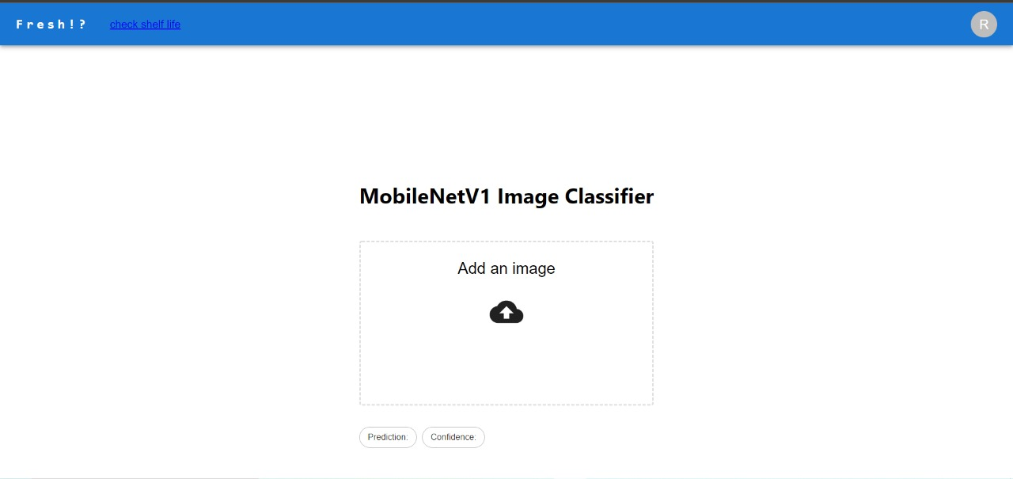

Fig 6.1 Quality Analysis of the fruit (Home Page)

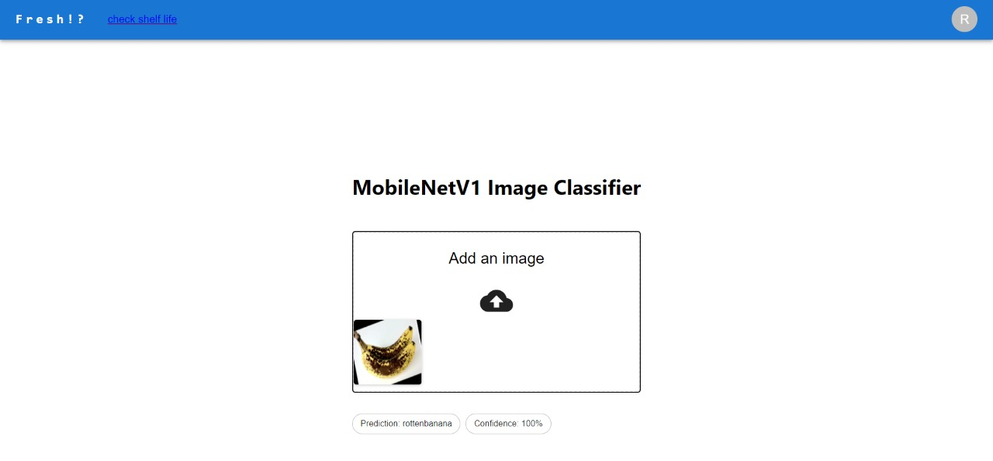

Fig 6.2 Quality of the fruit (shows rotten banana)

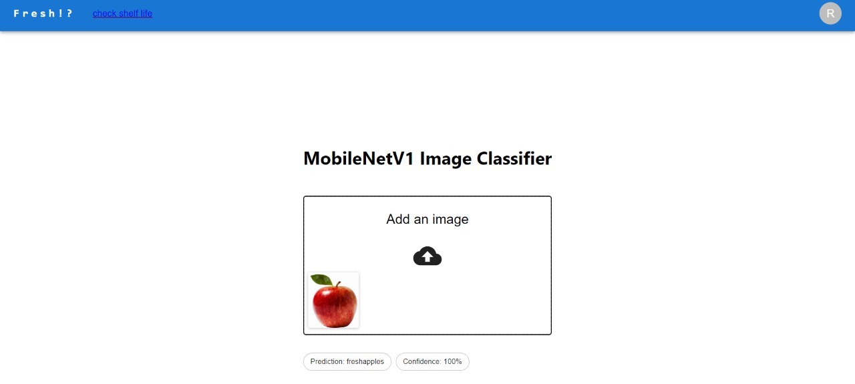

Fig 6.3. Quality of the fruit (shows fresh apple)

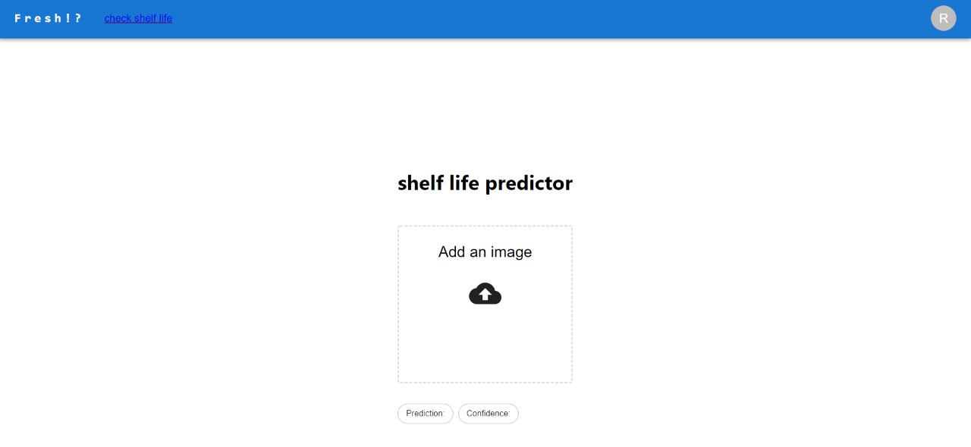

Fig 6.4. Shelf life predictor image

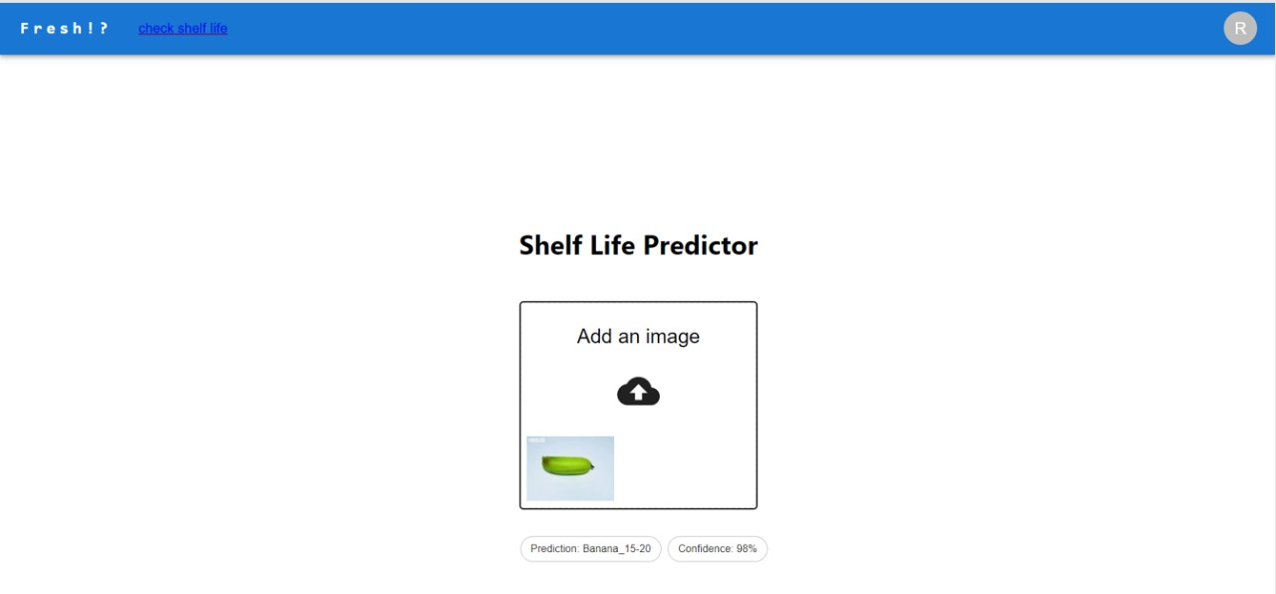

Fig 6.5. Shelf life of unripe banana fruit

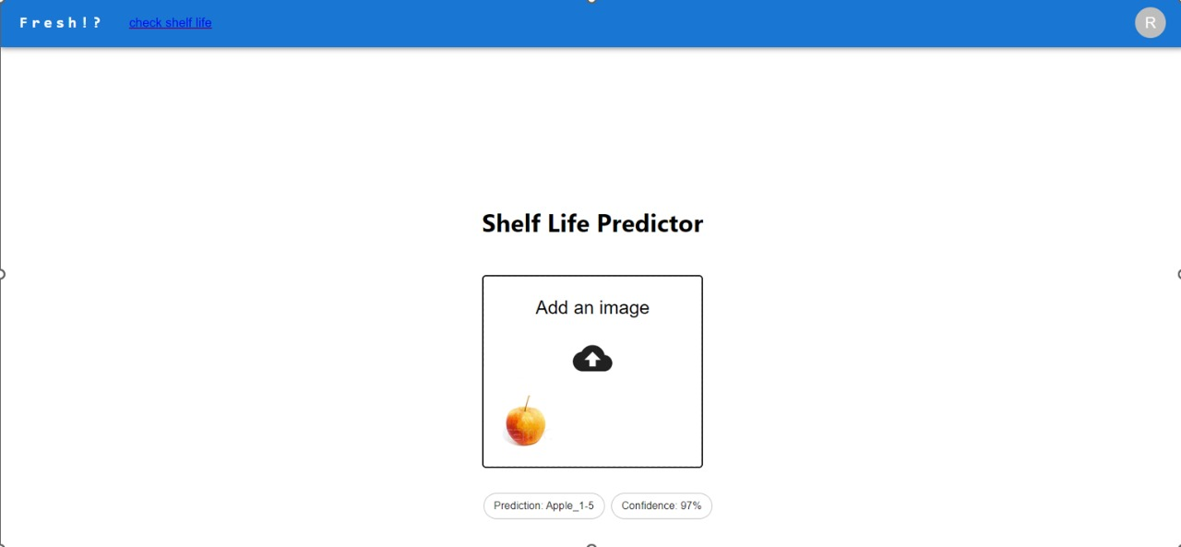

Fig 6.6. Shelf life of fresh apple fruit

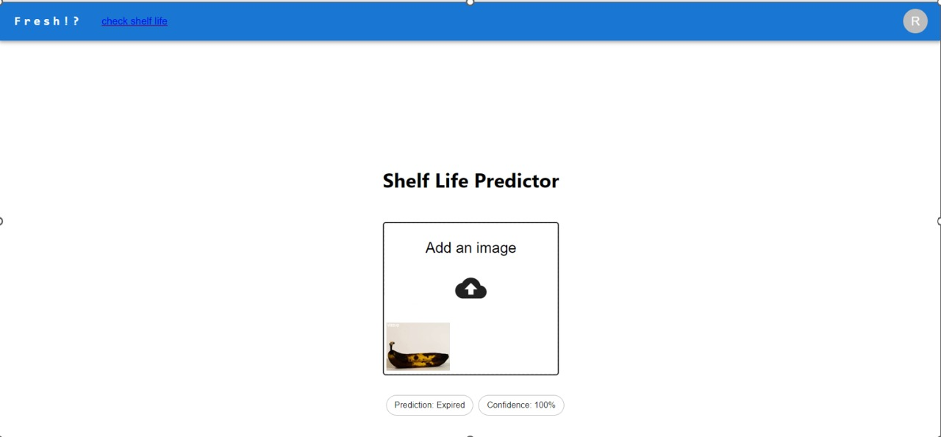

Fig 6.7. Shelf life of rotten banana fruit(shows expired)

# CHAPTER 7

## RESULTS AND CONCLUSION

The main aim of the project is to check the quality of the fruits. Also predict the shelf life of the same by capturing the image and feeding it to our model. By predicting the shelf life of the fruit and vegetable, we can determine the duration for which the quality of the fruits/vegetables will be fit enough to be sold to the customers. The project has attained high accuracy of 99.58% for image classification and 80.79 % accuracy for shelf-life prediction.

# CHAPTER 8

## FUTURE SCOPE

The project has attained high accuracy of 99.58% for image classification and 80.79 % accuracy for shelf-life prediction. Future plans include training the model on a bigger dataset to predict shelf-life more accurately, as well as implementing the model using hardware to be used in storage facilities.

# REFERENCES

* + 1. Nazrul Ismail & Owais A.Malik, "Real-time visual inspection system for grading fruits using computer vision and deep learning techniques",IEEE March 2022.
    2. Mukesh KumarTripathi and Dr Dhananjay D.Maktedar, "A role of computer vision in fruits and vegetables among various horticulture products of agriculture fields: A survey ",IEEE June 2020.
    3. Santi Kumari Behera, Amiya Kumar Rath and Prabira Kumar Sethy,. "Maturity status classification of papaya fruits based on machine learning and transfer learning approach " ,IEEE June 2021.
    4. M. Shamim Hossain, Muneer Al-Hammadi and Ghulam Muhammad, "Automatic Fruit Classification Using Deep Learning for Industrial Applications",IEEE October 2018.
    5. Fatma M. A. Mazen & Ahmed A. Nashat, "Ripeness Classification of Bananas Using an Artificial Neural Network",IEEE January 2019.
    6. S. Marimuthu and S. M. Roomi, "Particle swarm optimized fuzzy model for the classification of banana ripeness", IEEE Sensors J., vol. 17, no. 15, pp. 4903-4915, Aug. 2017.
    7. Manali Shaha and Meenakshi Pawar,"Transfer Learning for Image Classification",IEEE: 2nd Conference,April 2018.
    8. Sajja Tulasi Krishna and Hemantha Kumar Kalluri, "Deep Learning and Transfer Learning Approaches for Image Classification", ISSN:2277-3878,Februry 2019.
    9. Shweta S.Deulkar, Sunita S. Barve, "Feature based Fruit Quality Grading System using Support Vector Machine ",3rd IEEE International Conference, pp. 96-104, 2018.
    10. W. Zhang, J. Hu, G. Zhou, and M. He, ‘‘Detection of apple defects based on the FCM-NPGA and a multivariate image analysis,’’ IEEE Access, vol. 8, pp. 38833–38845, 2020.
    11. Yo-Ping Huang;Tzu-Hao Wang;Haobijam Basanta, "Using Fuzzy Mask R-CNN Model to Automatically Identify Tomato Ripeness",IEEE 2020.
    12. A F. Garcia, J. Cervantes, A. Lopez, and M. Alvarado, ‘‘Fruit classification by extracting color chromaticity, shape and texture features: Towards an application for supermarkets,’’ IEEE Latin Amer. Trans., vol. 14, no. 7, pp. 3434–3443, Jul. 2016.
    13. M. B. Garcia, S. Ambat, and R. T. Adao, ‘‘Tomayto, tomahto: A machine learning approach for tomato ripening stage identification using pixel-based color image classification,’’ in Proc. IEEE 11th Int. Conf. Humanoid, Nanotechnol., Inf. Technol., Commun. Control, Environ., Manage. (HNICEM), Laoag, PA, USA, Nov. 2019.
    14. F. Garcia, J. Cervantes, A. Lopez, and M. Alvarado, ‘‘Fruit classification by extracting color chromaticity, shape and texture features: Towards an application for supermarkets,’’ IEEE Latin Amer. Trans., vol. 14, no. 7, pp. 3434–3443, Jul. 2016. P. Li et al., "Deep convolutional computation model for feature learning on big data in internet of things", IEEE Trans. Ind. Inform., vol. 14, no. 2, pp. 790-798, Feb. 2018.
    15. Z. Gao, L. Wang, L. Zhou and J. Zhang, "HEp-2 cell image classification with deep convolutional neural networks", IEEE J. Biomed. Health Inform., vol. 21, no. 2, pp. 416-428, Mar. 2017.
    16. C. Hu, X. Liu, Z. Pan, and P. Li, ‘‘Automatic detection of single ripe tomato on plant combining faster R-CNN and intuitionistic fuzzy set,’’ IEEE Access, vol. 7, pp. 154683–154696, Oct. 2019.
    17. X. Liu, D. Zhao, W. Jia, W. Ji, and Y. Sun, ‘‘A detection method for apple fruits based on color and shape features,’’ IEEE Access, vol. 7, pp. 67923–67933, 2019.
    18. G. Muhammad, "Date fruits classification using texture descriptors and shape-size features", Eng. Appl. Artif. Intell., vol. 37, pp. 361-367, 2015.
    19. V. Leemans and M.-F. Destain, ‘‘A real-time grading method of apples based on features extracted from defects,’’ J. Food Eng., vol. 61, no. 1, pp. 83–89, Jan. 2004.
    20. D. Li, M. Shen and X. Yu, ‘‘Green apple recognition method based on the combination of texture and shape features,’’ in Proc. IEEE Int. Conf. Mechatron. Automat. (ICMA), Takamatsu, Japan, pp. 264–269, Aug. 2017.

# ACKNOWLEDGEMENT

We take this opportunity to express our profound gratitude and deep regards to our Director Padma Reddy A M for his guidance, monitoring and constant encouragement throughout the course of this thesis. The blessing, help and guidance given by her time to time shall carry us a long way in the journey of life on which we are about to embark. We also would like to thank our HOD Dr. K. Shanta Kumar B Patil for providing his constant support and expert guidance.

We also take this opportunity to thank our project guide Prof. Kshama S B for his cordial support, valuable information and guidance, which helped us in completing this ask through various stages. We are obliged to staff members of our Computer Department, for the valuable information provided by them in their respective fields. We are grateful for their cooperation during the period of our assignment. Lastly, we thank almighty, my parents, siblings and friends for their constant encouragement without which this assignment would have not been possible.

(Vaishnavi A-1VA18CS053)

( Santhosh K -1VA18CS039 )

( Suhas M – 1VA18CS048 )

(Tejas Manu S- 1VA18CS052 )